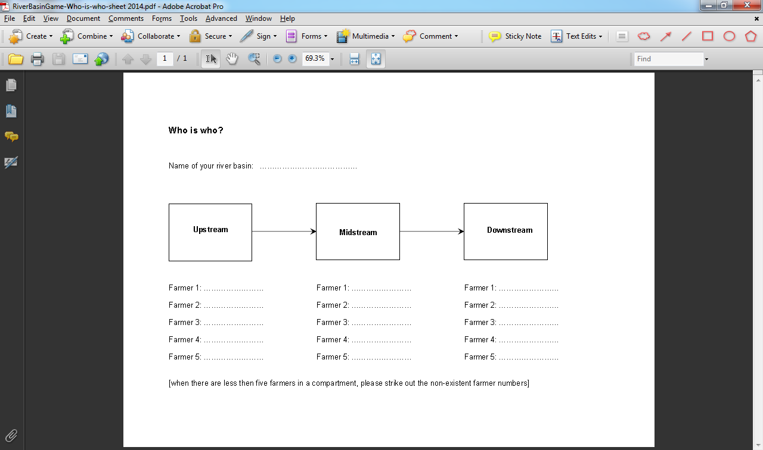

**River basin #1 (RB1) Enforcement officer:**

|  |  |  |  |  |  |  |  |  |
| --- | --- | --- | --- | --- | --- | --- | --- | --- |
| **Upstream** | **103 $/yr** | **Student Name** | **Midstream** | **103 $/yr** | **Student Name** | **Downstream** | **103 $/yr** | **Student Name** |
| Farmer U.1 | 30 |  | Farmer M.1 | 18 |  | Farmer D.1 | 6 |  |
| Farmer U.2 | 24 |  | Farmer M.2 | 12 |  | Farmer D.2 | 6 |  |
| Farmer U.3 | 16 |  | Farmer M.3 | 10 |  | Farmer D.3 | 6 |  |
| Farmer U.4 | 12 |  | Farmer M.4 | 8 |  | Farmer D.4 | 6 |  |
| Farmer U.5 | 12 |  | Farmer M.5 | 6 |  | Farmer D.5 | 6 |  |



**River basin #2 (RB2) Enforcement Officer:**

|  |  |  |  |  |  |  |  |  |
| --- | --- | --- | --- | --- | --- | --- | --- | --- |
| **Upstream** | **103 $/yr** | **Name** | **Midstream** | **103 $/yr** | **Name** | **Downstream** | **103 $/yr** | **Name** |
| Farmer U.1 | 30 |  | Farmer M.1 | 18 |  | Farmer D.1 | 6 |  |
| Farmer U.2 | 24 |  | Farmer M.2 | 12 |  | Farmer D.2 | 6 |  |
| Farmer U.3 | 16 |  | Farmer M.3 | 10 |  | Farmer D.3 | 6 |  |
| Farmer U.4 | 12 |  | Farmer M.4 | 8 |  | Farmer D.4 | 6 |  |
| Farmer U.5 | 12 |  | Farmer M.5 | 6 |  | Farmer D.5 | 6 |  |

**Upstream**

**Costs of Living (x 103)**

Farmer 1 ($30)

Farmer 2 ($24)

Farmer 3 ($16)

Farmer 4 ($12)

**Midstream**

**Costs of Living (x 103)**

Farmer 1 ($18)

Farmer 2 ($12)

Farmer 3 ($10)

Farmer 4 ($8)

**Downstream**

**Cost of Living (x 103)**

$6 / farmer

**River Basin #1**

**River Basin #2**